SAVEETHA SCHOOL OF ENGINEERING

**SAVEETHA INSTITUTE OF MEDICAL AND SCIENCES**

**CHENNAI-602105**

**INSTITUTE OF ARTIFICIAL INTELLIGENCE AND DATA SCIENCE DEPRATMENT OF DATA SCIENCE**

Course code/Name: CSA08/ Python Programming

1. A bakery sells loaves of bread for 185 rupees each. Day old bread is discounted by 60 percent. Write a python program that begins by reading the number of loaves of day old bread being purchased from the user. Then your program should display the regular price for the bread, the discount because it is a day old, and the total price. All of the values should be displayed using two decimal places, and the decimal points in all of the numbers should be aligned when reasonable values are entered by the user.

**Sample Input:**

Enter the number of fresh loves purchased: 5 Enter the number of day old loaves purchased: 3

**Sample Output:**

Regular price: Rs.185.00

Amount of new loaves: 925.00

Amount of day old loaves: 333.00 Total amount: Rs. 1258.00 **Test cases:**

* 1. 4,6
  2. -1,5
  3. 0,6 4. 7,8

5. 3,4

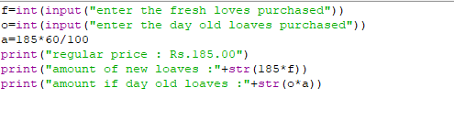

1. Given two strings “s” and “t”, determine if they are isomorphic. Two strings “s” and “t” are isomorphic if the characters in “s” can be replaced to get “t”. All occurrences of a character must be replaced with another character while preserving the order of characters. No two characters may map to the same character, but a character may map to itself.

Constraints

• s and t consist of any valid ascii character.

**Test Cases:**

1.Input: s = "egg", t = "add"

Output: true

2.Input: s = "foo", t = "bar"

Output: false

3.Input: s = "paper", t = "title"

Output: true

4.Input: s = "fry", t = "sky"

Output: true

5. Input: s = "apples", t = "apple" Output: false

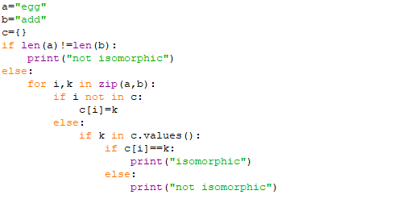

3. Given n non-negative integers a1,a2,a3,…an where each represents a point at coordinate (i, ai) . ‘ n ‘ vertical lines are drawn such that the two endpoints of line i is at (i, ai) and (i,0).

Find two lines, which together with x-axis forms a container, such that the container contains the most water. The program should return an integer which corresponds to the maximum area of water that can be contained (maximum area instead of maximum volume sounds weird but this is the 2D plane we are working with for simplicity).

**Note:** You may not slant the container.

**Test case:**

1**.**Input: array = [1, 5, 4, 3]

Output: 6

2.Input: array = [3, 1, 2, 4, 5]

Output: 12

3.Input: array = [1,8,6,2,5,4,8,3,7]

Output: 49

4.Input: array = [1,1]

Output: 1

5.Input: array = [7,3] Output: 3

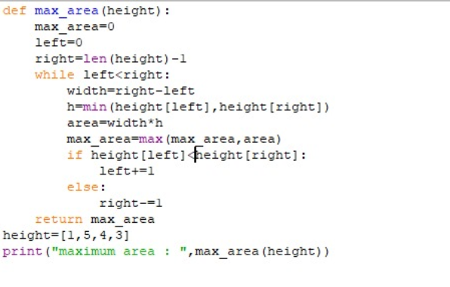

4.You are climbing a staircase. It takes n steps to reach the top. Each time you can either climb 1 or 2 steps. In how many distinct ways can you climb to the top? **Test Case:**

1.Input: n = 2

Output: 2

2.Input: n = 3

Output: 3

3.Input: n = 4

Output: 5

4.Input: n = 1

Output: 1

5.Input: n = 5

Output: 8

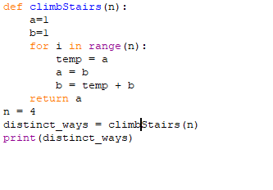

5. In daily share trading, a buyer buys shares in the morning and sells them on the same day. If the trader is allowed to make at most 2 transactions in a day, whereas the second transaction can only start after the first one is complete (Buy->sell->Buy->sell). Given stock prices throughout the day, find out the maximum profit that a share trader could have made. **Test Case:**

1.Input: prices = [7,1,5,3,6,4]

Output: 7

2.Input: prices = [7,6,4,3,1]

Output: 0

3.Input: [10, 22, 5, 75, 65, 80]

Output:87

4.Input: [2, 30, 15, 10, 8, 25, 80]

Output:100

1. Input: [5,25,3,10,7,9] Output:27

|  |  |  |
| --- | --- | --- |
| ,  s | u) |  |
| s[ | i+1] |  |

1. Given an integer n, return the number of strings of length n that consist only of vowels (a, e, i, o and are lexicographically sorted.

A string is lexicographically sorted if for all valid i, s[i] is the same as or comes before in the alphabet.

**Test Cases:**

1. Input: n = 1

Output: 5

Explanation: The 5 sorted strings that consist of vowels only are ["a","e","i","o","u"].

2. Input: n = 2

Output: 15

Explanation: The 15 sorted strings that consist of vowels only are

["aa","ae","ai","ao","au","ee","ei","eo","eu","ii","io","iu","oo","ou","uu"].

Note that "ea" is not a valid string since 'e' comes after 'a' in the alphabet.

3. Input: n = 33

Output: 66045

4. n=-5

5. n=10

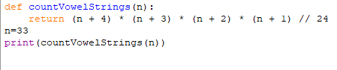

7. Given two binary strings a and b, return their sum as a binary string. • a and b consist only of '0' or '1' characters.

• each string does not contain leading zeros except for the zero itself. **Test cases:**

1.Input: a = "11", b = "1"

Output: "100"

2.Input: a = "1010", b = "1011"

Output: "10101"

3.a= “1111”, b= “1010”

4.a= “101101”, b= “1100”

5.a= “1011” b= “1111”

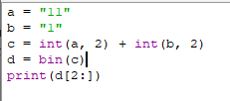

8. Basic Calculator II

Given a string s which represents an expression, evaluate this expression and return its value.

The integer division should truncate toward zero.

|  |  |  |
| --- | --- | --- |
| [-231 | , 231 | - 1] |

You may assume that the given expression is always valid. All intermediate results will be in the range of .

* s consists of integers and operators ('+', '-', '*', '/') separated by some number of spaces.
* s represents a valid expression.

|  |  |
| --- | --- |
| [0, 231 | - 1] |

* All the integers in the expression are non-negative integers in the range . • The answer is guaranteed to fit in a 32-bit integer.

|  |
| --- |
| eval( |

Note: You are not allowed to use any built-in function which evaluates strings as mathematical expressions, such as ).

**Test cases:**

1.Input: s = "3+2*2"

Output: 7

2.Input: s = " 3/2 "

Output: 1

3.Input: s = " 3+5 / 2 "

Output: 5

4.s= “-1+5”

5.s= “2+3+5”

9.

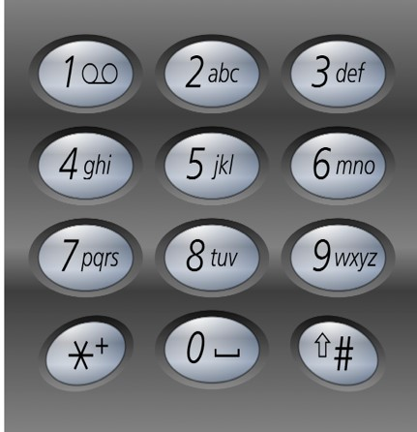

**Test Cases:**

1.Input: digits = "23"

Output: ["ad","ae","af","bd","be","bf","cd","ce","cf"]

2.Input: digits = ""

Output: []

3.Input: digits = "2"

Output: ["a","b","c"]

4.Input: digits = "9"

Output: ["w","x","y",”z”]

5.Input: digits = "87"

|  |  |  |  |  |  |  |  |  |  |  |  |  |  |  |  |  |  |
| --- | --- | --- | --- | --- | --- | --- | --- | --- | --- | --- | --- | --- | --- | --- | --- | --- | --- |
| vs | ”,“ | vr | ”,” | vq | ”, “ | vp | ”, “us”, “ | ur | ”, “ | uq | ”, “up”, “ | ts | ”, “tr | ”, “ | tq | ”, “ | tp |

Output: [“” ]

10. Given an integer n, return the least number of perfect square numbers that sum to n. A perfect square is an integer that is the square of an integer; in other words, it is the product of some integer with itself. For example, 1, 4, 9, and 16 are perfect squares while 3 and 11 are not.

**Test cases:**

1.Input: n = 12 output: 3

2. Input: n = 13, Output: 3

3.Input : n= 1, Output: 1

4.Input: n=4, Output: 2

5.Input: n=3, Output: 1

1. Find the Mth maximum number and Nth minimum number in list and then find the sum of it and difference of it.

Sample Input:

list of elements = [14, 16, 87, 36, 25, 89, 34]

* 1. = 1
  2. = 3

Sample Output:

1st Maximum Number = 89

3rd Minimum Number = 25

Sum = 114

Difference = 64

Test cases:

* + 1. [16, 16, 16 16, 16], M = 0, N = 1
    2. [0, 0, 0, 0], M = 1, N = 2
    3. [-12, -78, -35, -42, -85], M = 3 , N = 3
    4. [15, 19, 34, 56, 12], M = 6 , N = 3
    5. [85, 45, 65, 75, 95], M = 5 , N = 7

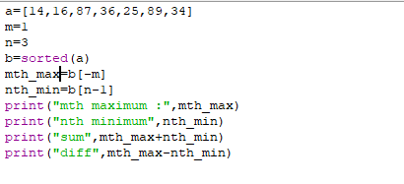

1. Write a program to read a character until a **\*** is encountered. Also count the number of uppercase, lowercase, and numbers entered by the users.

Sample Input:

Enter * to exit…

Enter any character: W

Enter any character: d

Enter any character: A

Enter any character: G

Enter any character: g

Enter any character: H Enter any character: * Sample Output:

Total count of lower case:2

Total count of upper case:4 Total count of numbers =0 Test cases:

1. 1,7,6,9,5
2. S, Q, l, K,7, j, M
3. M, j, L, &, @, G
4. D, K, I, 6, L, *
5. *, K, A, e, 1, 8, %, *

13. Write a program to read the numbers until -1 is encountered. Find the average of positive numbers and negative numbers entered by user.

Sample Input:

Enter -1 to exit…

Enter the number: 7

Enter the number: -2

Enter the number: 9

Enter the number: -8

Enter the number: -6

Enter the number: -4

Enter the number: 10

Enter the number: -1 Sample Output:

The average of negative numbers is: -5.0

The average of positive numbers is : 8.66666667 Test cases:

1. -1,43, -87, -29, 1, -9
2. 73, 7-6,2,10,28,-1
3. -5, -9, -46,2,5,0
4. 9, 11, -5, 6, 0,-1
5. -1,-1,-1,-1,-1
6. Raju, has again started troubling people in your city. The people have turned on to you for getting rid of Raju. Raju presents to you a number consisting of numbers from 0 to 9 characters. He wants you to reverse it from the final answer such that the number becomes Mirror number. A Mirror is a number which equals its reverse. The hope of people are on you so you have to solve the riddle. You have to tell if some number exists which you would reverse to convert the number into Mirror **Sample input:**

Enter the number: 123456 **Sample output:**

Mirror image: 654321 **Test cases:**

* 1. Sell123
  2. 5489236
  3. Abc-abc
  4. %$$$$^&
  5. -123456

1. Write a program to read a character until a **\*** is encountered. Also count the number of uppercase, lowercase, and numbers entered by the users.

**Sample Input:**

Enter the number of rows: 5 Enter the row number: 4 **Sample Output:**

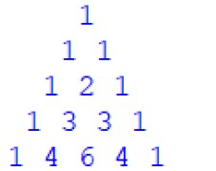

Sum of elements in 4th row: 8

**Test Cases:**

1.0, -1

1. 7,5
2. -1,5
3. 9, -5
4. 10, 8

16.An online retailer provides express shipping for many of its items at a rate of 750 for the first item, and 200 for each subsequent item. Write a function that takes the number of items in the order as its only parameter. Return the shipping charge for the order as the functions result. Include the code that reads the number of items purchased from the user and displays the shipping charge. All float values are displayed correct to 2 decimal places.

**Sample Input**

10

**Sample Output** 2550

**Test Cases:**

* 1. 45
  2. -12
  3. 12
  4. 0
  5. 56

17. Write a python function called matches that takes two strings as arguments and returns how many matches there are between the strings. A match is where the two strings have the same character at the same index.

**Test Cases:**

1. Input: s1= “what” s2= “watch”

Output: 1

2.Input: s1= “ ran” s2= “van”

3. Input : s1 = “ rain” s2 = “ turn”

4.Input : s1 = “ python” s2 = “py”

5. Inpput: s1= “man” s2= “women”

18. Write a python program to print the factorial of n and number of factors for n? Sample input:

N=6

Sample output:

6 Factorial: 720

Number of factors for 6: 4 Test cases:

1. N=0
2. N=-5
3. N=1
4. N=20
5. N=3A
6. Write a python program to Print the pattern:

Sample Input:

Enter the starting number: 1.4 Max number of line printed: 3 Sample output:

1.4

1.5 1.6

1.7 1.8 1.9 Test Cases:

* + 1. 5.6, 4
    2. 0.8, -1
    3. 1.9, 0
    4. 3.4, 5
    5. 7.8 3

1. Write a python program to print the first n perfect numbers and its first m factors.

Sample Input:

N=3, M=4

Sample Output:

First 4 factors of 6 are: 1,2,3,6

First 4 Factors of 28 are: 1,2,4,7 First 4 Factors of 496 are: 1,2,4,8 Test Cases:

* + 1. N=0, M=3
    2. N=4, M=4
    3. N=12, M=3
    4. N=-5, M=3
    5. N=0.2, M=-4